Microsoft ] 下載 Windows 7 SP1 多國語言包與修改語言介面 ( LP語言包 )
Download Windows 7 SP1 MUI Language Packs ( LP語言包 )
下載 Windows 7 SP1 多國語言包
官網 Download languages for Windows - Microsoft Windows
性質 freeware 免費 / en 多國 繁體中文(Traditional Chinese) / Windows 7 SP1 LP語言包
Windows 7 SP1 MUI Language Pack 微軟官方語言包下載 for 32 bit (x86)
Windows 7 SP1 英文語言包 English
Windows 7 SP1 繁體中文語言包 Chinese (Traditional)
Windows 7 SP1 簡體中文語言包 Chinese (Simplified)
Windows 7 SP1 日文語言包 Japanese
Windows 7 SP1 MUI Language Pack 微軟官方語言包下載 for 64 bit (x64)
Windows 7 SP1 英文語言包 English
Windows 7 SP1 繁體中文語言包 Chinese (Traditional)
Windows 7 SP1 簡體中文語言包 Chinese (Simplified)
Windows 7 SP1 日文語言包 Japanese
更換 Windows 7 SP1 語言介面的方法
直接安裝語言包，或由控制台 > 地區及語言 > 鍵盤及語言 > 安裝及解除語言
如果沒有出現"安裝及解除語言"選項，就要用修改的 = =+
注意本篇為測試 Windows 7 SP1 語言系統，不具備教學意義，僅為整理心得分享使用ψ(._. )> 筆記
請了解修改 Windows 7 SP1 系統語言有所風險，務必在修改之前備份好所有系統與資料，並建議修改後就別再改回來了，挺麻煩的呀@@"
修改 Windows 7 SP1 語言介面的方法
1. 這裡以 Windows 7 SP1 繁體中文修改為英文為例，下載欲修改的英文語言包並執行
在 lp.cab 檔出現的一瞬間，複製一份出來放到 C:\

2. 以系統管理員執行 command line ，輸入以下指令，靜待完成，
如圖所示，出現 The operation completed successfully.
DISM /Online /Add-Package /PackagePath:C:\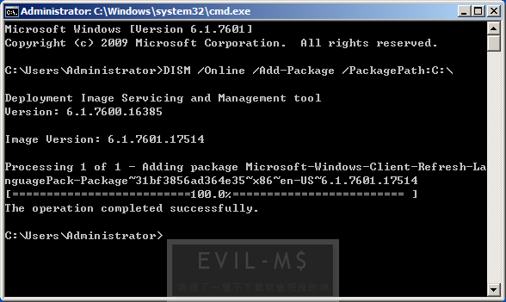
3. 修改 Windows 7 開機語言，分別輸入下列兩行指令，如圖要出現成功的字眼
The operation completed successfully. 以及 Boot files successfully created.
( 欲修改為簡體中文的，兩行指令的最後分別為 zh-CN )
bcdedit /set {current} locale en-USbcdboot %WinDir% /l en-US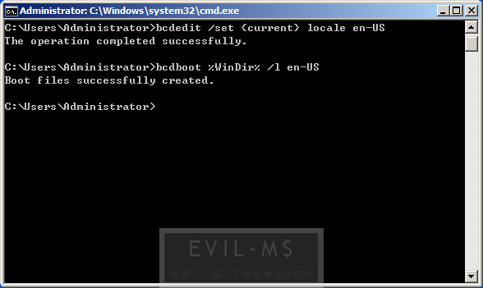
4. 開啟 regedit 登錄檔，刪除不必要的語言介面 (此行為刪除 Windows 7 SP1.Del.MUI.zh-TW.reg 繁體中文為例)Windows Registry Editor Version 5.00
[-HKEY_LOCAL_MACHINE\SYSTEM\CurrentControlSet\Control\MUI\UILanguages\zh-TW]
5. 重新開機，修改完成 (￣▽￣)b (讚)
PS1. Windows 7 SP1 Language Packs Hash Table ( KB2483139 語言包雜湊值 )
==================================================
Filename : windows6.1-kb2483139-x86-en-us.exe
MD5 : 1DC10871673E687C13F8005421D319A2
SHA1 : 783D6DD59E2EC8FB0995A059C9C121795BDE46C8
File Size : 163,310,888
File Version : 6.1.7601.17535 (win7sp1_gdr_oob_w7sp1lp(oobla).110112-1524)
Product Version : 6.1.7601.17535
==================================================
==================================================
Filename : windows6.1-kb2483139-x64-en-us.exe
MD5 : 75FF4408E2155ADC3870F16F61656E52
SHA1 : 9B9C8A867BAFF2920507FBF1E1B4A158572B9B87
File Size : 171,510,568
File Version : 6.1.7601.17535 (win7sp1_gdr_oob_w7sp1lp(oobla).110112-1523)
Product Version : 6.1.7601.17535
==================================================
==================================================
Filename : windows6.1-kb2483139-x86-zh-hk.exe
MD5 : EB83570C42AF6B6FE0E02423D0C68746
SHA1 : 411A6BB68728F12F5CED712D9A33FEE9EBE0B0B3
File Size : 121,746,728
File Version : 6.1.7601.17535 (win7sp1_gdr_oob_w7sp1lp(oobla).110112-1524)
Product Version : 6.1.7601.17535
==================================================
==================================================
Filename : windows6.1-kb2483139-x64-zh-hk.exe
MD5 : B1AA0E15ECDD5641024E32C5D7B8164D
SHA1 : 285282B1E2F750EEED91466918443B657968D977
File Size : 196,504,360
File Version : 6.1.7601.17535 (win7sp1_gdr_oob_w7sp1lp(oobla).110112-1523)
Product Version : 6.1.7601.17535
==================================================
==================================================
Filename : windows6.1-kb2483139-x86-zh-cn.exe
MD5 : 00291F42E6022956EDE082C035E170EC
SHA1 : AE61EA226215F96FC95BE33201FFC96755AC7EB5
File Size : 151,302,952
File Version : 6.1.7601.17535 (win7sp1_gdr_oob_w7sp1lp(oobla).110112-1524)
Product Version : 6.1.7601.17535
==================================================
==================================================
Filename : windows6.1-kb2483139-x64-zh-cn.exe
MD5 : 9AB4D1F7CDA19BC125D7ED64F3A5B065
SHA1 : 2C1884B4FDF6C8E91986369D88BBCAAE01C6F187
File Size : 174,587,176
File Version : 6.1.7601.17535 (win7sp1_gdr_oob_w7sp1lp(oobla).110112-1523)
Product Version : 6.1.7601.17535
==================================================
PS2. Windows 7 SP1 原本為繁體中文版的 regedit 參考如下
Windows Registry Editor Version 5.00
[HKEY_LOCAL_MACHINE\SYSTEM\ControlSet001\Control\MUI\UILanguages\zh-TW]
"LCID"=dword:00000404
"Type"=dword:00000112
[HKEY_LOCAL_MACHINE\SYSTEM\ControlSet002\Control\MUI\UILanguages\zh-TW]
"LCID"=dword:00000404
"Type"=dword:00000112
[HKEY_LOCAL_MACHINE\SYSTEM\CurrentControlSet\Control\MUI\UILanguages\zh-TW]
"LCID"=dword:00000404
"Type"=dword:00000112
PS3. Windows 7 SP1 修改為英文版後的 regedit 參考如下 Windows 7 SP1.MUI.en-US.reg
Windows Registry Editor Version 5.00
[HKEY_LOCAL_MACHINE\SYSTEM\ControlSet001\Control\MUI\UILanguages\en-US]
"LCID"=dword:00000409
"Type"=dword:00000091
[HKEY_LOCAL_MACHINE\SYSTEM\ControlSet002\Control\MUI\UILanguages\en-US]
"LCID"=dword:00000409
"Type"=dword:00000091
[HKEY_LOCAL_MACHINE\SYSTEM\CurrentControlSet\Control\MUI\UILanguages\en-US]
"LCID"=dword:00000409
"Type"=dword:00000091
PS4. Windows 7 SP1 修改為簡體中文版後的 regedit 參考如下 Windows 7 SP1.MUI.zh-CN.reg
Windows Registry Editor Version 5.00
[HKEY_LOCAL_MACHINE\SYSTEM\ControlSet001\Control\MUI\UILanguages\zh-cn]
"LCID"=dword:00000804
"Type"=dword:00000092
[HKEY_LOCAL_MACHINE\SYSTEM\ControlSet002\Control\MUI\UILanguages\zh-cn]
"LCID"=dword:00000804
"Type"=dword:00000092
[HKEY_LOCAL_MACHINE\SYSTEM\CurrentControlSet\Control\MUI\UILanguages\zh-cn]
"LCID"=dword:00000804
"Type"=dword:00000092
張貼者： KAMANCY 於 下午2:30
標籤： CMD, DOWNLOAD, HASH, LANGUAGE, MICROSOFT, REGEDIT, WINDOWS 7

